

NAME: AJAY KUMAR REDDY
REG NO:192425274
COURSE CODE: MLA0214
COURSE NAME: FUNDAMENTAL OF MACHINE LEARNING

QUESTION:
Demonstrate the working of the decision tree based ID3 algorithm. Use an appropriate data set for building the decision tree and apply this knowledge to classify a new sample.
AIM:
To implement a Decision Tree using ID3 algorithm and classify a new sample.
ALGORITHM:
- Start the program.
- Load the dataset.
- Convert categorical data into numeric form.
- Train the Decision Tree model.
- Provide a new sample input.
- Predict the class using the trained model.
- Display the prediction.

CODE:
import pandas as pd
from sklearn.tree import DecisionTreeClassifier
data = {
'Outlook':['Sunny','Sunny','Overcast','Rain'],
'Temp':['Hot','Hot','Hot','Mild'],
'Play':['No','No','Yes','Yes']
}
df = pd.DataFrame(data)
X = pd.get_dummies(df[['Outlook','Temp']])
y = df['Play']
model = DecisionTreeClassifier()
model.fit(X,y)
sample = pd.get_dummies(pd.DataFrame([['Sunny','Hot']],columns=['Outlook','Temp']))
sample = sample.reindex(columns=X.columns,fill_value=0)
print("Prediction:",model.predict(sample))
OUTPUT: 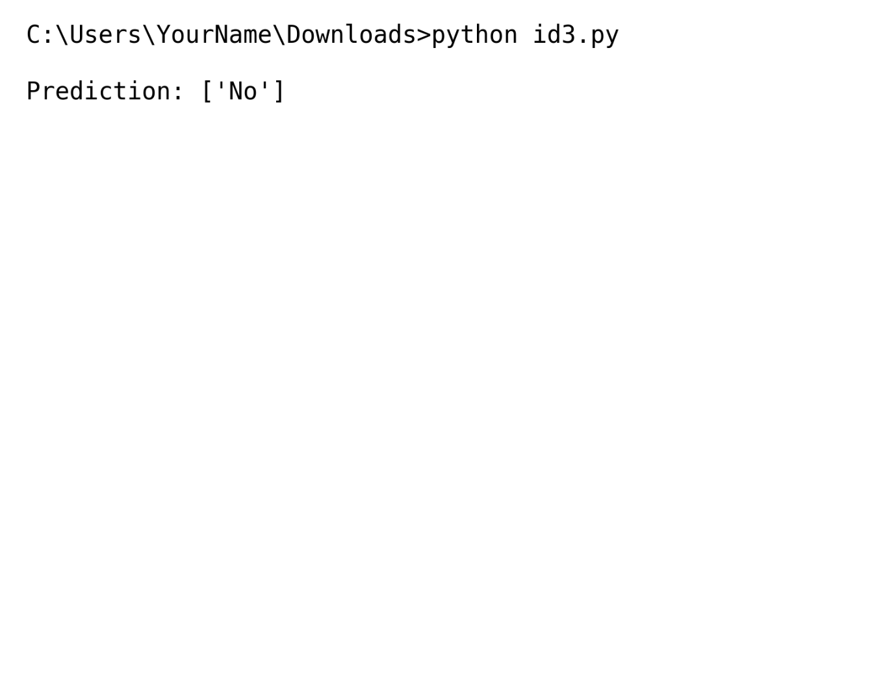
RESULT: The decision tree model is built successfully and predicts the class for the given sample.

